Week 4 Partial Solution
Health Claims
For health claims, it is very important to calculate the reserve for the claims incurred but not paid yet. Actuaries usually get the claim data in four columns (incurred month, paid month, paid, amount, and inventory). The actuators need to rearrange the data in triangle tables of the information.
Assume we get the claim data on sheet “Claim Data”. The data includes the information on claim incurred month, claim paid month, paid claim amount, and inventory on the cell range B4:D282. It also includes the membership on each incurred month. A part of the sample of data is shown below.
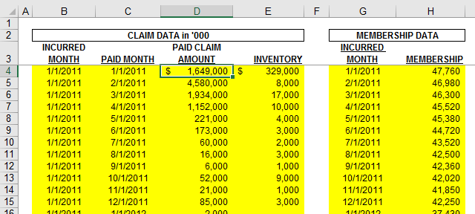
We need to arrange the data in two triangle tables:
- Table “Total Paid claims by month of payment and incurred month, and membership by month” is presented with Paid Claims by Month of Payment and Month of Service ("Paid Claims Triangle") (in thousands of dollars).
- Table “Inventory levels by reporting month and incurred month” is presented with Inventory by Reporting Month and Incurred Month ("Inventory Claims Triangle") (in thousands of dollars).
We will need to look up both the incurred month and the paid month when we build table, and both the incurred month and the reporting month in the second table. However, we could not use a regular lookup formula to find two pieces of information at the same time. The biggest hurdle is to deal with this issue in this application. We are going to combine the two searching keys into one by combining the incurred month and the paid month into on in cell range B75:B353. The formula in cell B75 is below.
=VALUE('Claim Data'!B4)&VALUE('Claim Data'!C4)
Let’s build the first table in the cell range B5:AA33.
- Cell range C5:AA5 is a merged cell to show “Incurred Month” for column heading.
- Cell B6 shows “Paid Month” and C6 shows Total to mean column C chows the total of each corresponding row. Row 31 shows the total for each corresponding column.
- Cell range B7:B30 contains the paid months. We can put the smallest paid month date in cell B7, which can be changed by users, if needed, to get the information for different periods. The formula in B8 is just to set one month forward from B7. The formula can be “=EDATE(B7,1)”.
- Cell range D7:AA7 contains the incurred months. The ideas and formulas are similar to those in B7:B30.
- Now we come to the core of the table content in the range D7:AA30. The lookup formula in cell D7 is shown below, which also makes sure the “” is shown if no match is found.
=IF(ISERROR(MATCH(VALUE(D$6)&VALUE($B7),$B$75:$B$353,0)),"",INDEX('Claim Data'!$D$4:$D$282,MATCH(VALUE(D$6)&VALUE($B7),$B$75:$B$353,0)))
- Row 32 is blank row and row 33 shows the membership for each indicated month. The formula for D3 is shown below:
=VLOOKUP(D$6,'Claim Data'!$G$4:$H$27,2)/1000
This should complete building the first table. The second table should be built similar with similar tricks.
We should mention another approach by using an array formula, which can simplify the process by eliminating the need of the intermediate calculations in the range B75:B353. In this case, the lookup formula in cell D7 is replaced by an array formula below.
=IFERROR(INDEX('Claim Data'!$D$4:$D$282,MATCH(VALUE(D$6)&VALUE($B7),VALUE('Claim Data'!$B$4:$B$282)&VALUE('Claim Data'!$C$4:$C$282),0)),"")
Please remember that the array formula should be entered by CTRL + SHIFT + Enter when the formula is finished. That key combination put {} around the formula to mean it is an array formula. The manually entered {} will not work.

